To: HOA, Fall Creek Estates
From: Linda Afariebor
Date: June 22, 2021
Subject: Proposal to Provide Swimming Pool and Park in Fall Creek Neighborhood

SUMMARY OF THE PROPOSAL
The absence of recreational facilities including swimming pool and park in our neighborhood is making residents incur huge expenses in enjoying these facilities outside. The recent prevalence of crime in our society has made it pertinent for our neighborhood to have its own private recreational facility to keep our neighborhood as well as families safe. This proposal is for the provision of a swimming pool and park facility in Fall Creek. This proposal highlights the challenges residents encounter that has necessitated this proposal, and the feasibility study of the project.

DEFINITION OF THE PROBLEM/ SITUATION
In summer, Dallas weather is very hot and the need for a neighborhood swimming pool heightens. The problem of lack of swimming pool or park in our neighborhood is making residents to:
- Incur huge costs providing these necessities outside of the neighborhood
- Spend long hours commuting to other parts of town where these facilities are cheaper.
- Sometimes accessing public pools can be difficult because of the crowd.
- Ride bikes on the streets
During summer season (May 15th to September 15th), family membership of Keller Pointe (the closest swimming facility to the neighborhood) cost $350 to residents. While daily use cost $17 for family, $8 per adult, and $7 per youth.
Due to Covid 19 pandemic, most pools are open to only residents, and even when access is granted, it takes about 45mins commuting to these facilities.
The most devastating part of accessing pools outside of the neighborhood is that there is a long line of people who need access to same facility, and they cut off admission to the facility after a certain time. This means everybody on the line after the cut-off time will not have access to the facility that day, even though they have been on the queue waiting patiently under the scorchy sun for hours.
Most of the residents in the neighborhood have school age children, who mostly ride their bikes on the street because there is no other play area around the neighborhood to do so. This is very dangerous because children stand the chance of being hit by reckless drivers, and this can either be fatal or may lead to mild or serious injuries.
OBJECTIVES
A neighborhood swimming pool and park will enable residents have a common place of social interaction, connection, and foster communal bond. It will make residents enjoy the neighborhood better and help to save miscellaneous expenses incurred outside. The risk of accidents will be reduced because residents can ride their bikes, walk, run, and exercise at the park. Residents can walk to the facility, thereby saving the time used in long commutes outside and well as transportation costs. Residents will feel safer and secured in the neighborhood park than outside.
- According to Westby, M.D., “water-based exercise such as swimming can have positive effects on mental health, such as strengthening family bonds between children with developmental disabilities and their parents.” (2001).
- The American Planning Association believes that “The conspicuous presence of people outdoors contributes further to safety by increasing surveillance, which discourages criminals.” (pg. 4).
- According to the Association for Childhood Education International, “ Play also teaches children how to interact and cooperate with others, laying foundations for success in school and the working world” (Joan, Packer I., et al (2002).
- Briggs said, “swimming has a multitude of benefits. It is a low-impact activity. It improves cardiovascular fitness. It improves your muscular strength and endurance.” (Natalie, 2016)
There are vacant lands in our neighborhood that can be used to achieve the goal of providing a swimming pool and park for the neighborhood. To promote this course, some steps need to be taken by residents including:
- An agenda regarding this proposal will be discussed in the next HOA meeting, and residents will be given opportunities to make their contributions.
- A column of the Keller neighborhood newspapers will feature this proposal for residents to contribute their thoughts.
- Residents can also fill out surveys online representing their interests and submitting same through email to HOA.

PROPOSED SPACE FOR LOCATION OF SWIMMING POOL AND PARK

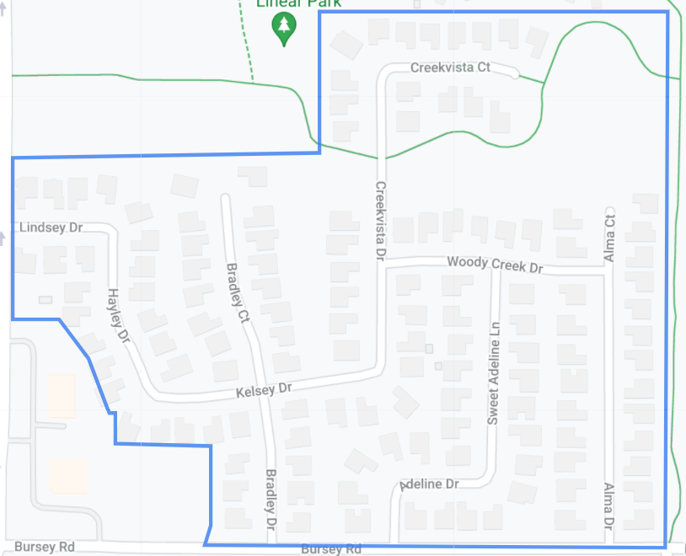
(See Alt Text: for description)

THREATS AND WEAKNESSES
There are two likely threats to this proposal. Firstly, the HOA unwillingness to approve the proposal due to cost of building and maintenance, as well as likelihood of attracting uncontrollable crowd into the neighborhood. Secondly, some residents who own private swimming pools may not consent to the proposal for fear of attracting unwanted visitors to the neighborhood, thereby compromising the tranquility of the neighborhood.
If this proposal is approved, these threats can be mitigated by fencing the facility and employing security guards to control the facility. The facility will have only one entry and exit. Residents will be assigned an admittance card, which they will present to the security guards upon entry to or exit from the facility.

NEEDS ASSESSMENT
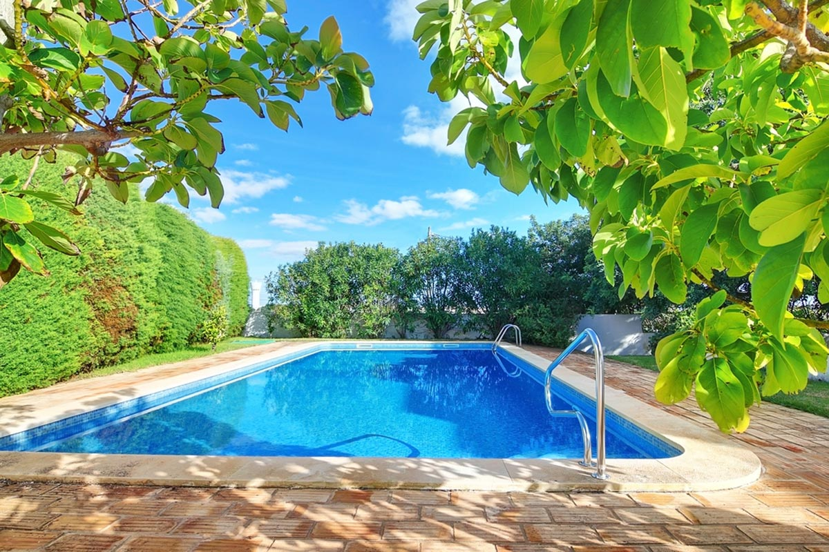

THE BUDGET
Table 1: INGROUND POOL COST INSTALLATION
THE TIMELINE
Average time to build a pool | 8-12 weeks
- Design| 1-4 weeks
Obtain residential building permit

- Permitting| 2-6 weeks
Break ground for pool installation

- Excavation| 1 week
Break ground for pool installation
- Steel, Plumbing, Electrical| 1-2 weeks
Lay steel, route electrical and plumbing

- Gunite, Plaster, Vinyl, Fiberglass| 1-3 weeks
Time to install the swimming pool! Concrete cures one-week post-installation

- Deck, Landscape, Features| 1-3 weeks
Add landscaping, water features, lighting, etc.

PERSONNEL / MISCELLANEOUS COSTS INVOLVED IN A POOL
Other personnel involved in the building of a swimming pool as well as miscellaneous prices include pool covers, building permits, electrician fees, increased insurance, etc.
- The electrician does electrical work to bring power to the pool for the pump and filter : $2,200.
- Pool building permits from the building department at the local city, or any other local governing authorities : range between $500 and $2,000.
- Water heater, as well as upgrade to a 300amp, if there is insufficient capacity at the breaker panel: $6,000.
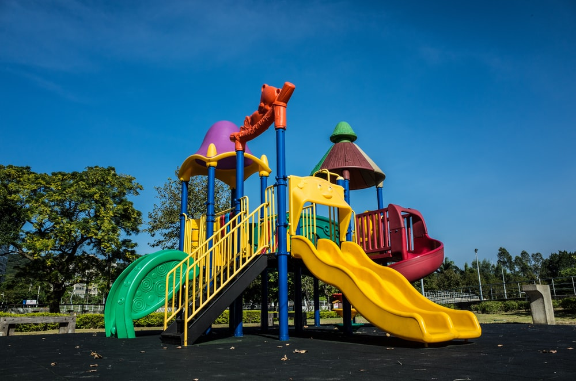
https://unsplash.com/s/photos/playground
THE BUDGET – A standard commercial playground costs between $35,000 and $85,000
Playground budget breakdown:
Shade| 13% of the project
Surfacing| 15% of the project
Installation| 27% of the project
Shipping| 5% of the project
THE TIMELINE – The usual estimate for a playground project is around 6 to 9 months.

CONCLUSION
The need for a swimming pool and park in Fall Creek Estate cannot be over-emphasized and hence should be approved. There is need for homeowners to be familiar with one another. A park and swimming pool provides a platform for families to socially interact. Children in modern America, are glued to social media and technological devices, a park and swimming pool will shift their focus to health promoting activities. Children will be able to make neighborhood friends and protect the interest of their neighborhood. A neighborhood recreational facility provides additional comfort and safety to residents compared to procuring such outside their neighborhoods. These benefits of having a neighborhood swimming pool and park outweighs the drawbacks that may impede it. Kindly approve this project as I am willing to continue with it and welcome feedback on my ideas. For additional questions and enquiries, I can be reached at linda.afariebor@my.tccd.edu .

REFERENCES
American Planning Association; How Cities Use Parks to Create Safer Neighborhoods; “How
Cities Use Parks to Create Safer Neighborhoods.” pp. 4. https://www.brec.org/assets/General_Info/Why_R_Parks_Important/Papers/Parks-Create-Safer-Neighborhoods.pdf . Accessed 23 June 2021
Centers for Disease Control and Prevention; “Health Benefits of Water-based Exercise.”
https://www.cdc.gov/healthywater/swimming/swimmers/health_benefits_water_exercise.html. Accessed 23 June 2021.
Joan, Packer I., et al; “Play: Essential for All Children,” Association for Childhood Education
International (2002), http://www.udel.edu/bateman/acei/playpaper.htm. Accessed 22 June 2021.
Natalie , McGill; “Swimming: Stay afloat for better health.” The Nation’s health Vol. 46, Issue
4, 2016, pp. 24. https://www.thenationshealth.org/content/46/4/24 . Accessed 23 June 2021.
Westby, M D. “A health professional's guide to exercise prescription for people with arthritis: a
review of aerobic fitness activities.” Arthritis and rheumatism vol. 45,6 (2001): 501-11. doi:10.1002/1529-0131(200112)45:6<501::aid-art375>3.0.co;2-y. Accessed 22 June 2021.

Wednesday, June 23, 2021, www.kellercitizen.com Volume 33, Number 44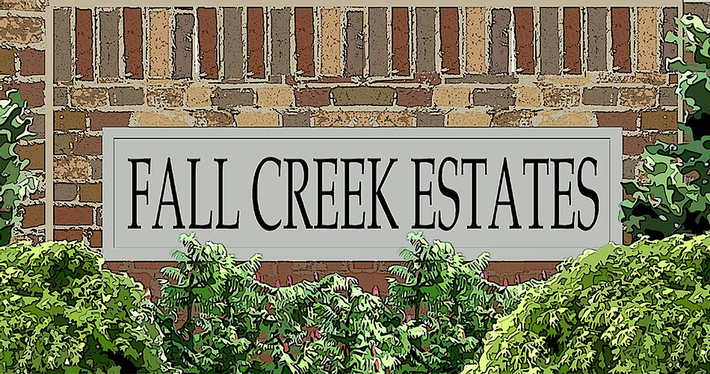
CITY OF KELLER Welcome to Fall Creek Estates
Rachael Reynolds, in KELLER
Public Information Officer an HOA Community
817-743-4146
rreynolds@fallcreekestateshoa.com

Press Release: Fall Creek Estate Opens New Neighborhood Swimming Pool and Park on Saturday May 7, 2022

Keller, TX (June 23, 2021) – Fall Creek Estates HOA is pleased to announce the opening of the outdoor Bradley D. Court Municipal pool at the Fall Creek Estate Park commencing on Saturday, May 7, 2022. The Pool and Park will be situated at the Northwest corner of Fall Creek Estates. The building project is expected to commence on Saturday, July 24, 2021. “This is a first-class facility that we are proud to offer to residents” said Mayor Armin Mizani. “Summer memories are waiting to be made as we work to make this vision a reality.”
For further enquiries, kindly contact Fall Creek Estates HOA at 817-743-4146.

